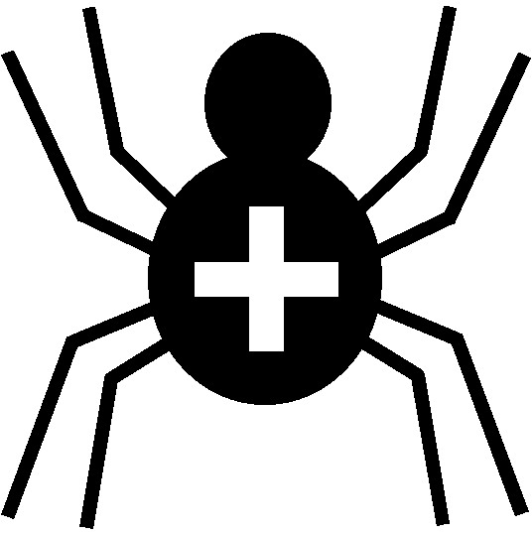

Silver Cross Scout Centre

Activity Risk Assessment

Activity | Air-gun target shooting (.177) | Venue | On-site

Hazard | Who might be harmed | Controls | Revue and revision
Puncture wound (direct) | Participants, instructor, other spectators | Minimised by instructor’s briefing | agreed
Puncture wound (ricochet) | Participants, instructor, other spectators | All rebound surfaces protected and baffled | agreed
Jamming fingers in breach | Participant | Minimised by instructor’s briefing | agreed
Ricochet to eye | Participant, instructor | Safety glasses to be worn. Minimised by drapes and baffling. | agreed

Other controls in place | Dedicated range. Instructors are first-aid trained. First-aid kit in Range.
Rev 09
Nov 2024

