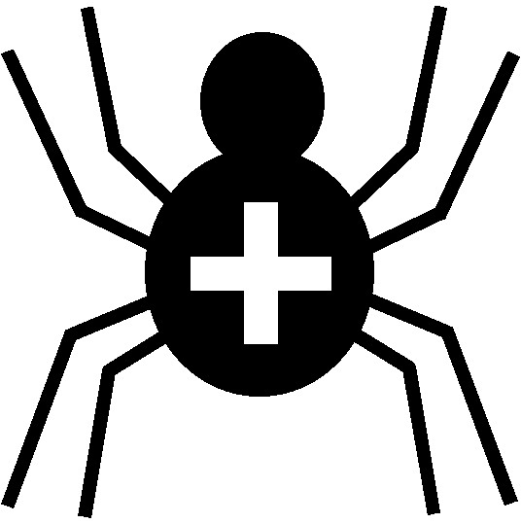

Silver Cross Scout Centre

Activity Risk Assessment

Activity | Archery | Venue | On site

Hazard | Who might be harmed | Controls | Revue and revision
Weather | All present in activity | Instructor to ensure weather is suitable for the activity. All members to wear suitable clothing and non-restrictive to handling of the equipment. Long hair to be tied back, neckers tucked in, jackets zipped up | agreed
Environment | Any/all spectators and participants | The instructor must pre-brief the group about the dangers that may be present in the immediate area in which the activity is taking place | agreed
Arrow (point) causing puncture wound | Spectators, other participants, instructor | Minimised by instructor’s briefing. Continuous assessment of equipment and range. | agreed
Arrow (nock) causing puncture wound | participant | Minimised by instructor’s briefing. Continuous assessment of equipment. | agreed
Bowstring friction burn to finger or forearm | participant | On-string finger protectors and bracers must be used. Instructor visual assessment to minimise harm. | agreed
Bowstring friction burn to chest | participant | Minimised by instructor’s briefing. Instructor visual assessment to minimise harm. | agreed
Boss falling over | participant, instructor | Stand suitable secured in place, boss fixed to stand | agreed

Other controls in place | Dedicated range. Side barriers to archery range clearly marked. Instructors are first-aid trained. First-aid box.
Rev 09
Nov 2024

