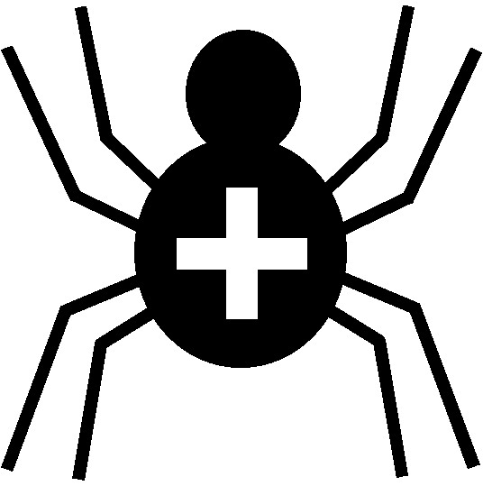

Silver Cross Scout Centre

Activity Risk Assessment

Activity | Campfire Circle | Venue | On site

Hazard | Who might be harmed | Controls | Revue and revision
Burns / heat injury | Any / all individuals | Leaders in charge of Campfire to ensure fires are not too big and fully under control.  Fire Safety is the responsibility of the leader in charge of the Campfire.  Individuals to be at a safe distance from the fire (especially while doing “stunts” etc) | agreed
Falling on wet ground | Any / all individuals | Caution to be taken in Campfire Circle in wet weather | agreed
Falling off logs, seats etc | Any / all individuals | Leaders ensure that no-one stands on seats, logs etc. – for sitting only. | agreed
Need to evacuate Campfire Circle | Any / all individuals | Leaders to ensure everyone knows exits from Campfire Circle and location of main muster point outside Toilet Block | agreed

Other controls in place | First-aid available in Site Office.  Individual groups should have their own First-aid and emergency procedures.
Rev 09
Nov 2024

