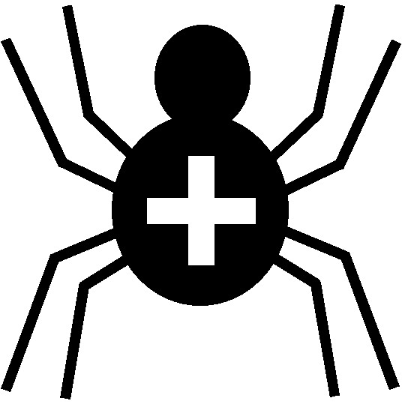

Silver Cross Scout Centre

Activity Risk Assessment

Activity | Crate Stacking | Venue | On-site

Hazard | Who might be harmed | Controls | Revue and revision
Being struck by falling equipment, climber or loose items | Any / all individuals | Everybody must wear correctly-fitted helmets at all times.  Supervisor must ensure a safe area for group to remain while not climbing or supplying crates.  Supervisor must ensure that crates are passed up safely to climber using poles etc. and not thrown up. | agreed
Falling out of climbing harness | Participant | Supervisor to ensure that harnesses are correctly fitted and adjusted before climbing takes place – this to include every time harness is removed. Full-body harness to be used. | agreed
Equipment failure | Any / all individuals | Supervisor responsible for ensuring that equipment is logged, stored and repaired/replaced as necessary and conforms to CE / UK CA regulations.  Warden to ensure that all equipment used is suitable for the activity and complies with the necessary safety standards.  Supervisor must ensure that all equipment used is checked and inspected for damage before and after use. | agreed
Anchor failure and integrity of belay point | Any / all individuals | Health and suitability of belay tree to be checked on a regular basis by recognised tree surgeon. Supervisor will physically check the anchor points are sound at start of each session. | agreed
Belayer pulled off balance / unable to hold a fall | Belayer | Area used for belaying to be free of obstacles.  Belayer to use permanent supplied anchor and not belay un-anchored. Belayer to ensure no excessive slack in the system. | agreed
Rev 09
Nov 2024
Other controls in place | Instructors are first-aid trained.  First-aid kit carried.

