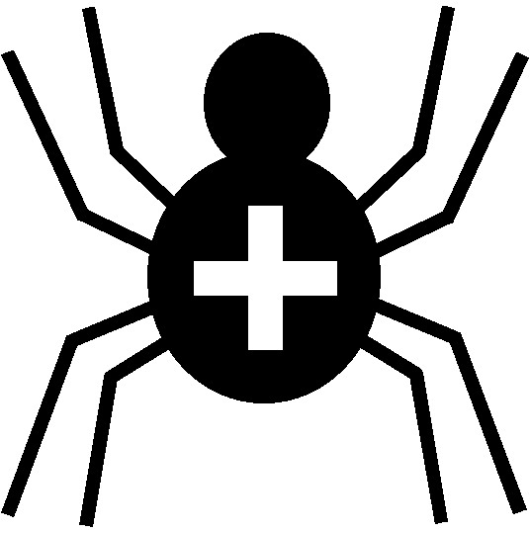

Silver Cross Scout Centre

Pembroke Building Risk Assessment

Risk Area | Pembroke Building | Venue | On site

Hazard | Who might be harmed | Controls | Revue and revision
Slipping on wet floor in shower in Pembroke Building | Any / all individuals | Signs to be put out when cleaning in progress. | agreed
Injury in kitchen of Pembroke Building | Any / all individuals | Leaders of individual groups to ensure safety in kitchen at all times, especially near stove / hot surfaces | agreed
Possible crush injury/trampling when evacuating Pembroke Building in event of fire | Any / all individuals | Leaders to ensure that all residents are familiar with emergency evacuation of building and to arrange their own fire drill as soon as possible after arriving. | agreed
Smoke inhalation from burning furniture | Any / all individuals | All mattresses and soft furnishings to be fire resistant | agreed
Unable to exit Building in an emergency | Any / all individuals | Fire exits to be kept clear at all times.  Bags and/or bedding to be stored tidily and away from any thoroughfares  Maximum number of people in Pembroke Building is 40 at any time. | agreed

Other controls in place | All buildings where access is possible to be maintained and checked regularly for any faults / damage.  Fire alarms / smoke detectors / carbon monoxide detectors maintained regularly.  Fire extinguishers and fire alarm system maintained by Chubb service people regularly.
Rev 09
Nov 2024

