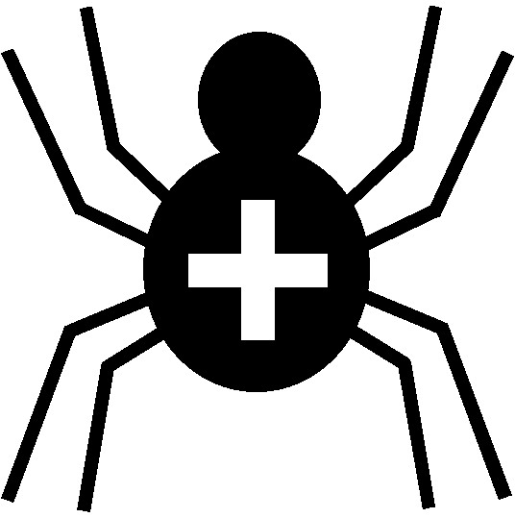

Silver Cross Scout Centre

Buildings Risk Assessment – Shop

Risk Area | Site Tuckshop | Venue | On site

Hazard | Who might be harmed | Controls | Revue and revision
Tripping / Falling on access ramp | Any / all individuals | Wire netting on access ramp to avoid slipping | agreed
Crush injury in shop | Any / all individuals | Maximum numbers allowed in shop at any one time (depending on how many serving). Keep exit door clear for customers to leave easily.

Other controls in place | All buildings where access is possible to be maintained and checked regularly for any faults / damage.
Rev 09
Nov 2024

