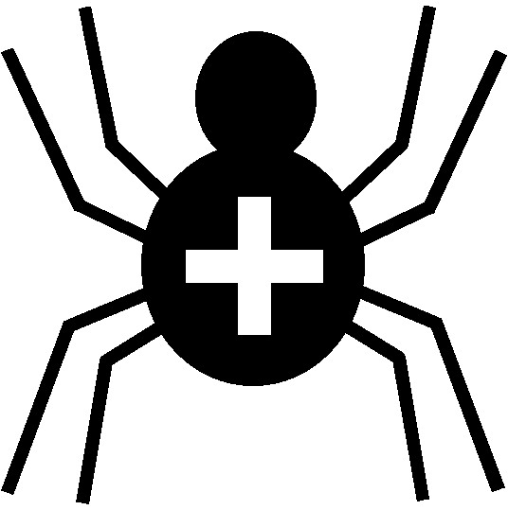

Silver Cross Scout Centre

Activity Risk Assessment

Activity | Splatapult Paintball | Venue | On site

Hazard | Who might be harmed | Controls | Revue and revision
Paint in eye from burst paintball | Participant / Leader in charge | Safety glasses must be worn. Paintballs must be non-toxic and water based. Safety glasses to be worn by leader in charge next to shooting point. | revised
Injury to hand from catapult | Participant | Minimised by initial briefing | agreed
Injury to another by paintball | All | Paintballs only to be shot at designated targets. Paintballs NOT to be aimed at people. | agreed
Straying into Tomahawk Range | All | Initial briefing to include about the dangers that may be present in the immediate area in which the activity is taking place. Participants must remain in designated waiting area when not shooting. | agreed

Other controls in place | Dedicated range. First-aid box in Rifle Range and in Stone Tent (Office)
Rev 04
Nov 2024

