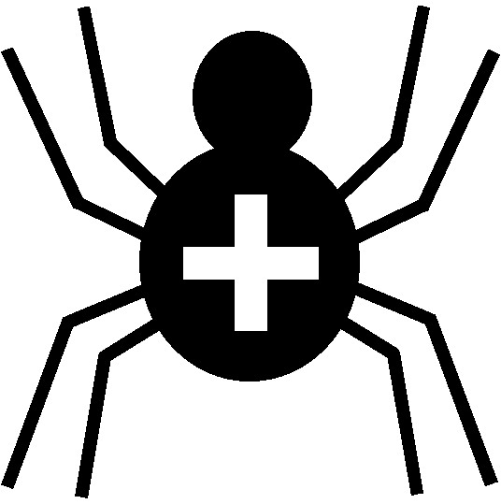

Silver Cross Scout Centre

Activity Risk Assessment

Activity | Tomahawk Throwing | Venue | On site

Hazard | Who might be harmed | Controls | Revue and revision
Weather | All present in activity | Instructor to ensure weather is suitable for the activity. All members to wear suitable clothing and footwear and non-restrictive to handling of the equipment. No open-toed footwear. | revised
Environment | Any/all spectators and participants | The instructor must pre-brief the group about the dangers that may be present in the immediate area in which the activity is taking place.  Participants waiting their turn must stay in designated waiting areas. | agreed
Straying into Splatapult Range | All | Participants must remain in designated waiting area when not shooting. | agreed
Weapon causing wound | Spectators, participant, other participants, instructor | Minimised by Range Safety Officer's briefing. Continuous assessment of equipment and range.  Only one hawk to be thrown at a target before retrieval. | agreed

Other controls in place | Dedicated range. Side barriers to tomahawk range clearly marked. Instructors are first-aid trained. First-aid box.
Rev 07
Nov 2024

