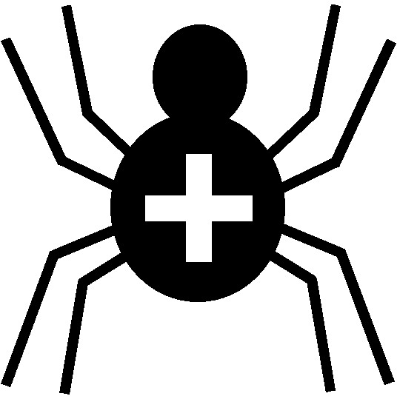

Silver Cross Scout Centre

Buildings Risk Assessment – Utilities Room

Risk Area | Laundry / Fridges & Freezers | Venue | On site

Hazard | Who might be harmed | Controls | Revue and revision
Tripping / Falling over clothing | Any / all individuals | Clothing piles to be stored tidily, not strewn on floor | agreed
Tripping / Falling on litter etc on floor | Any / all individuals | Litter kept to a minimum. Bin to be checked by rota cleaning team. No foodstuffs to be left in bin but disposed of properly | agreed
Foodstuffs out of date in fridges etc | Any / all individuals | Groups to dispose of any surplus foodstuffs properly at the end of their stay. Individuals clean any spilled foodstuffs in their fridge/freezer. | agreed

Other controls in place | All buildings where access is possible to be maintained and checked regularly for any faults / damage.
Rev 09
Nov 2024

